School Supply List
Kindergarten – Grade 2
1 pair of indoor shoes (non-marking)
Backpack
1 water bottle
12 pencils
4 white erasers
3 large glue sticks (not white glue)
1 set of pencil crayons
1 box of crayons
1 set of washable markers (thick)
1 pencil box/pencil case
2 boxes of Kleenex
1 scrapbook (large/no lines)
1 pair of scissors
1 personal pencil sharpener
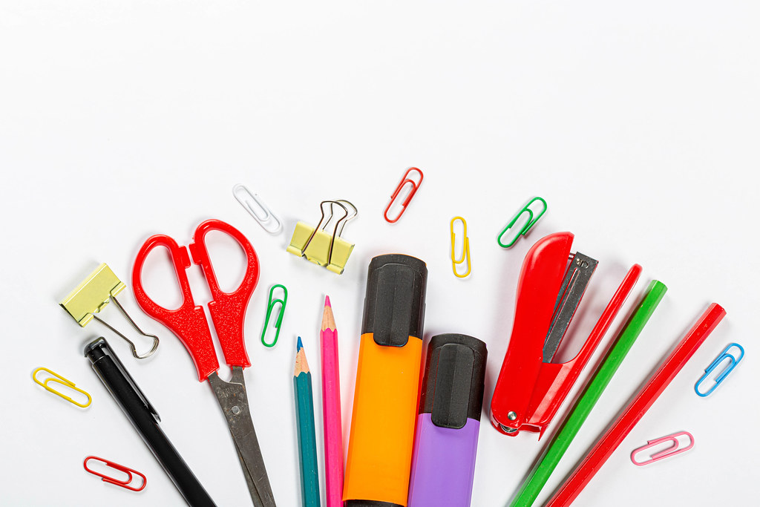
Lunch box/bag. Please note that our class does not have access to a microwave.

