School Supply List
Grade 3 & 4

1 pair of indoor shoes
1 water bottle
1 package of 24 pencils
4 large glue sticks
6 large white erasers
30 cm ruler
1 set of pencil crayons
1 box of crayons
1 pencil box
1 set of coloured markers
3 boxes of Kleenex
2 one subject notebooks
1 pair of scissors
1 personal pencil sharpener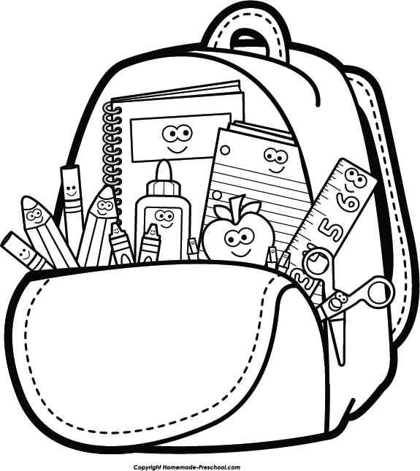
School Supply List
Grade 5 – 8

- 2 each: red, blue and black pens
- 1 pack of loose-leaf paper (150-200 sheet/pack)
- 1 large zippered binder
- 2 packs of subject dividers
- 30 cm metric ruler
- Geometric set
- Scissors
- 3 boxes of Kleenex
- Pencil crayons
- Markers
- 1 large glue stick
-1 personal hand sanitizer
-1 personal pencil sharpener
- Calculator
-1 pencil case

